SUNDAY, 8th March 2020

*The second Sunday of Lent*

Welcome to our Services

* * * * * * * * * * * * * * * * * * * * * *

9am Morning Communion

10.30am All Age Worship





[](https://www.google.co.uk/imgres?imgurl=https://dailyverse.knowing-jesus.com/w/dv_700/dailyverse-images/0d/Galatians%204-4%20God%20Sent%20Forth%20His%20Son%20gold.jpg&imgrefurl=https://dailyverse.knowing-jesus.com/galatians-4-4&docid=ptBRWdeJo_OC8M&tbnid=1x-qMPHNdhr7-M:&vet=10ahUKEwinvabku8TmAhW4QkEAHTB4B8YQMwhkKAEwAQ..i&w=700&h=525&bih=638&biw=984&q=Galatians%204%20picture&ved=0ahUKEwinvabku8TmAhW4QkEAHTB4B8YQMwhkKAEwAQ&iact=mrc&uact=8)

**THE READING THIS WEEK IS**

**Matthew 16: 13-20**

**“ Peter’s Confession of Christ”**

Prayer Ministry

Trained prayer ministers are available for you. If you would like someone to pray with you, ask our stewards for more details or follow the instruction during our communion services.

First time at St Paul’s?

Do let one of our friendly stewards know and they will be able to help you. Please join us for refreshments after our service.

spnh.org.uk

Today’s 9am Hymns

Opening Hymn: 470 Praise to the Lord, the Almighty

(Verses 1, 2 & 6)

Offertory Hymn: 362 Lord, the light of Your love is shining

(*Shine, Jesus Shine) – omit verse 2*

Final Hymn: 482 Rejoice the Lord is King – *omit verse 4*

Processional Music: Any other name *by Thomas Newman*

10.30am Service – All Age Worship

We have come to bless the Lord

1175 As for me and my house

2887 In my Wrestling *(My Lighthouse)*

The grace of God has reached for me *(*The Lord is my Salvation)

829 I stand amazed in the presence of Jesus the Nazarene



The week ahead

|  |  |
| --- | --- |
| Later today  4.00pm FELLOWSHIP TEA  MONDAY, 9th MARCH  9.00am Pre-School *All week*  *P.School are holding a Sports Day – supporting ‘Sport Relief’.*  *Mon-Fri. 11.45-12.15pm every day.*  5.30-7.30pm weight watchers  7.00pm-8pm GUIDES Parents’  Fundraising Meeting Church Hall  TUESDAY, 1oth MARCH  9.00am PRE-SCHOOL  5.30pm BROWNIES  5.45pm RAINBOWS  7.00pm RANGERS  8pm MEN’S GROUP lounge/O.B  *A monk, a sandwich and a diary -*  *Colin Smith* | WEDNESDAY, 11th MARCH  9.00am PRE-SCHOOL  9.15am COFFEE CALL  9.30am MORNING COMMUNION  7.30pm Alpha GroUP  8.00pm Cameo & Men’s GRoup  VISIT *to* *Erith Playhouse ’The*  *rise and fall of Little Voice*’  friday, 13th March  9.00am PRE-SCHOOL  12.30pm BEREAVEMENT LUNCH  7.30pm SCOUTS  SATURDAY, 14TH MARCH  9.45-12.30pm Alive n’Kicking  *(Church Hall and Lounge)*  ALPHA DAY / Weekend Away |
|  |  |

**CHURCH OF ENGLAND CORONAVIRUS INSTRUCTIONS** – **Please do not dip your bread during Communion. This increases the risk of cross infection. You can instead just receive bread. All Communion Assistants should use antibacterial gel before distribution.**

**THE ALPHA COURSE**

**THIS WEEK – Wednesday, 11th March @ 7.30pm**

***(How does God guide us?)***

**NEXT Saturday, 14th March - Alpha Day / Weekend Away**

Noticeboard



**MOTHERING SUNDAY FLOWERS: On Saturday 21st March, 9.30-10.30am** **in church, we are planning to make the posies which will be distributed at the Mothering Sunday Service on Sunday, 22nd March. Please come along and join us, no previous experience needed! Thanking you in anticipation. *Monica 01322 332108***

**‘BRING AND SHARE’ SUPPER – SUNDAY, 29TH MARCH**

**After the 6pm Confirmation Service on the above date, we are having a ‘Bring & Share’ Supper.**

**If attending the service and staying afterwards for the supper, a contribution of cold food would be appreciated, enabling us all to share our food with each other.**

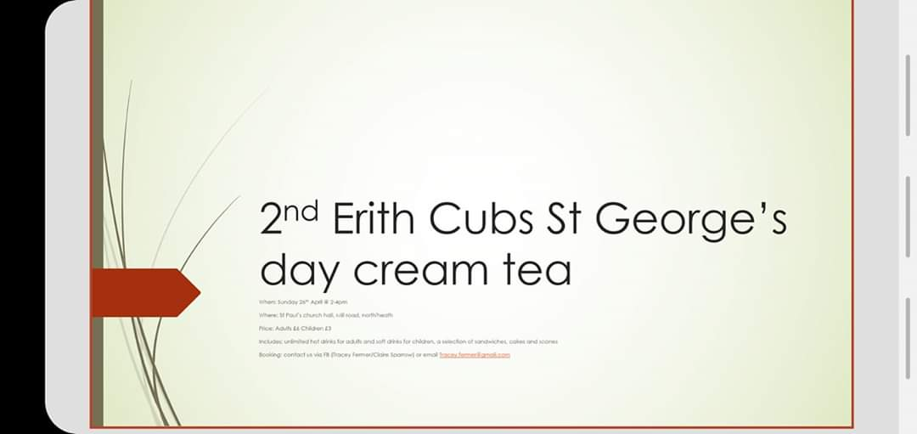

**2nd Erith Cub Group are hosting a St George’s Day Cream Tea on**

**Sunday, 26th April from 2.00pm-4.00pm. £6 per adult & £3 per child. Places need to be booked with Elaine Fermer.**

**This is a very popular event and therefore spaces are limited.**

 **SONGS OF PRAISE – Sunday, 3rd May 2020**

**@St Paul’s Church – 5.30pm Cream Tea: 6.30-8.00pm Songs of Praise**

**ALL WELCOME - Come along, bring friends and enjoy singing your favourite hymns and worship songs*. Cream tea is free but you will need to book your place. Contac****t:* ***Tim Luff on: 01322 552214 or*** [***luff.tim@yahoo.com***](mailto:luff.tim@yahoo.com)

***Parking in Council car park in Mill Road free after 6pm.***



**SONGS OF PRAISE**



Gift Aid it.

If you pay tax then your giving can be bumped up by the government at no extra cost to you. See Dot Turner or

Charles Brooke for more details.

PRAYER REQUESTS

Below is a list of people who have asked for you to pray for them.

Andrew Bennett, Charles Brooke, Elizabeth Foster and Joan Handy,

Marjorie and Eileen Hoare,

Monica Lindridge and Alex and

Wai Ming Martin,

Christine Meaton, Christine Minns,

Carol & John O’Connor, John Ralph and Jane & George Stafford.

Karen Vaughan (Cameo), Peggy Vidler, Jeanette Watts and Mark Williams.

Information

Vicar: Rev Clive Beazley-Long (Day off – Thursdays)

clive@spnh.org.uk 01322 634579

Reader: Lauraine Wells 01322 407861

Pastoral Assistant: Elizabeth Williams 01322 339796

Authorised Preacher: Charles Brooke

Authorised Preacher: Genevieve Sawyerr

Churchwarden: Colin Smith 01322 336505

Premises booking manager: Linda Mayes 07544393798

Administrator: Judy Cunnew 01322 336505

The church office is open, Mon. 9am-2pm, Wed. & Fri. 9am-3pm [office@spnh.org.uk](mailto:office@spnh.org.uk)

To save paper and receive our notice sheet by email please send a message to Judy in the office. *(adminstpaulnh@hotmail.co.uk).*

Any notices for Sunday 15th March, please e-mail office by Wednesday,

11th March.

For those wishing to give by bank transfer, our bank details are: Code 60-15-28 Account No: 66526434. Account Name: St Paul’s Church. Reference: your name

St Paul’s Church

Mill Road

Northumberland Heath

Erith

Kent

DA8 1HN

spnh.org.uk

www.facebook.com/stpaulsnorthumberlandheath