Ann's Simple Recipes

St Paul’s resident culinary queen Ann Easter shares some of her favourite recipes with you.

Quick Links

New Meat Balls & Spaghetti Lasagne
Banana Loaf Rhubarb Crumble Cake
Cottage Pie Coconut Apple, Apricot & Pistachio Loaf
Chicken, Ham & Mushroom Pie Quiche
Butternut Squash Soup Sultana Cake Toad In The Hole
Crispy Bacon & Feta Cheese Salad Honey Loaf
Prawn Pasta Salad

Banana Loaf
Ingredients
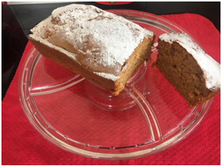
8oz / 220g Self raising flour
4oz / 120g Butter
4oz / 120g Brown sugar
2 Eggs
2 Soft bananas
1oz / 60g Icing sugar

Instructions

Sift the flour into a large mixing bowl.
Mash the bananas and add to the flour.
Add the sugar, eggs and butter and mix to a smooth batter.
Place the mix into a greased 2lb / 1kg loaf tin.
Bake at gas mark 4 / 160c for 50 minutes.
Check with a skewer that the cake is cooked.
When the cake has cooled turn out and sift icing sugar over the top.

Chocoholic?
Add chocolate chunks to the mix
and drizzle melted chocolate on the finished cake.

Top

Cottage Pie
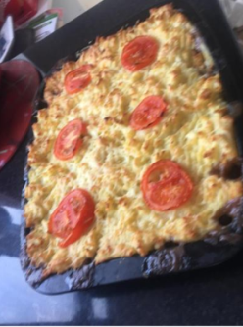
Ingredients
1lb / 450g Minced Beef
1 Large red onion
4oz / 120g Mushrooms
3 Dessert spoons of gravy granules
2lb Potatoes
2oz / 60g of Cheddar Cheese
1 Large Tomato
Instructions
Brown the mince in a pan with a little oil.
Chop the onion and mushrooms and add to the mince.
Make up the gravy with 16floz / 450ml boiling water and add to the mix.
Stir and place the mince mixture into a large oven tin.
Boil and mash the potatoes and then cover the mince filling.
Slice the tomato and place on the top.
Bake in an oven at gas mark 6 / 180c for 40 minutes.
“All my family love the cheese and tomato topping.
This is my go-to comfort food”
Top Tip: Use lamb mince for a tasty Shepherd’s pie
Top

Coconut cake
Ingredients
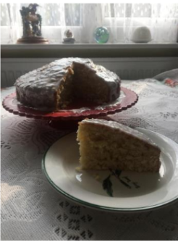
8oz / 225g Self raising flour
4oz / 120g Butter
2oz / 60g Desiccated coconut
2oz / 60g Sugar2 eggs
6oz / 170g Icing sugar

Instructions
Sift the flour into a mixing bowl.
Beat the eggs and add to the bowl along with the
sugar, butter and desiccated coconut.
Mix the ingredients well until they form a creamy consistency.
Grease a 7” / 18cm cake tin.
Add the mix and level with a spoon.
Bake at gas mark 4 for 1hour or 150c for 50 minutes.
Check with a skewer that the cake is cooked.
When the cake is cold, mix the icing sugar
with a small amount of water until it is a thin paste.
Mix in a handful of coconut and spread onto the cake.
Top

Apple, Apricot & Pistachio Loaf
“I make this Cake for Sarah, my daughter-in-law. She is wheat and gluten intolerant, but this recipe is gluten free. She find’s shop bought versions tasteless, but this recipe should give you a moist flavoursome cake.”
Ingredients
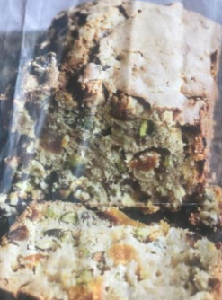
8oz / 225g Gluten free self-raising flour
4 tbsp vegetable oil
2 oz/ 60g Soft brown sugar
2 Large eggs
4oz/ 120g diced dessert apple
4oz/ 120g Dried apricots
4oz/ 120g Peeled Pistachios
Instructions
Sift the flour into a mixing bowl.
Beat the eggs and add to the bowl along with the sugar,
apple, apricots and pistachios.
Mix the ingredients well until they form a thick batter.
Using the oil grease a loaf tin.
Add the batter and level with a spoon
Bake in a low oven gas mark 2 / 150c for 1hour.
Check with a skewer that the cake is cooked.
Rest in the tin for 30 minutes before turning out.
Ann’s Top Tip
Instead of pistachio’s try other nuts such as walnuts or pecans
Top

Chicken, Ham & Mushroom Pie
Ingredients
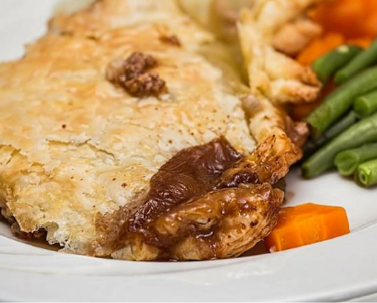
1lb / 500g Cooked chicken
4oz / 125g Chunky ham
2oz / 60g Mushrooms
8oz / 250g Frozen puff pastry
1 Egg
Thick gravy

Instructions
Dice the chicken and the ham and slice the mushrooms.
Mix the Chicken, ham and mushrooms with the gravy and pour the mixture into a pie dish.
Roll out the puff pastry and cover the mixture in the pie dish.
Beat the egg and brush onto the pastry top.
Bake in the oven for 45 minutes on gas mark 4 / 160°C
Top

Quiche
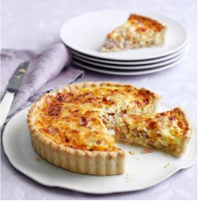
Ingredients
18oz (500g) Plain flour
7ozs (200g) Butter
Pinch of salt
2 Eggs
4ozs (120g) Mature cheddar
2 Rashers of bacon
1 Red onion
½ pint (280ml) of milk
Instructions
To make the pastry base Sift the flour into a large bowl
add the diced butter and rub in with your fingertips until the mixture resembles fine breadcrumbs. Stir in a pinch of salt,
then add 2-3 tbsp water and mix to a firm dough.
Knead the dough briefly and gently on a floured surface then roll out.
Line your flan tin(s) with the dough and bake for 15 minutes at gas mark 4 / 160°C. To make the filling Chop the bacon and the onion and beat the eggs. Mix the bacon, onions, eggs, cheese & milk in a large bowl.
Pour the mixture into the tin(s)and bake for 40 minutes on gas mark 5 / 170°C, till firm to the touch.
Try adding other ingredients such as peppers or broccoli.
Top tip: Use ready made pastry and simply roll it out.
Top

Butternut Squash Soup
“This is my favourite soup and is one of the easiest to make”
Ingredients
1 Butternut Squash –Approx. 1Kg
1 Large red onion
1 Pint of chicken stock
Croutons (optional)
Instructions
Dice the butternut squash & onion, then boil until soft.
Drain and allow to cool for a few minutes.
Place the squash and onion carefully in a blender and add the stock.
Blend until smooth.
Can be eaten straight away or refrigerated and
heated in a pan on a medium heat until bubbling.
Add croutons and enjoy.
Top tips: For an extra kick add some chilli flakes at blending stage.
Buy the butternut squash ready diced into cubes
Top

Sultana Cake
Ingredients
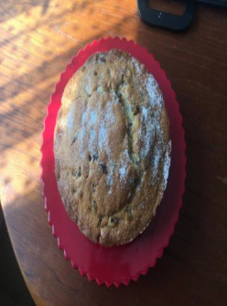
8oz / 250g Self raising flour
4oz / 120g Butter
4oz / 120g Sultanas
1 Large egg
2oz / 60g Sugar
1 teaspoon Mixed spice

Instructions
Beat the egg
Sift the flour into a large mixing bowl and add the other ingredients (including the egg).
Mix until you have a thick cake batter.
Place the batter into a 7” / 18cm greased cake tin.
Bake on gas mark 4 for 1 hour or 160c for 50mins.
Check with a skewer that the cake is cooked through.
When cool, turn your cake out and sprinkle some sugar on it to finish.
Top

Toad In The Hole
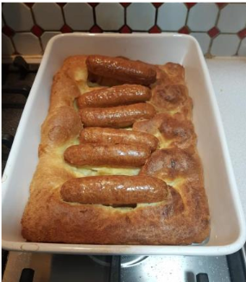
Ingredients
1lb / 500g
Sausages4oz / 120g plain flour
1 egg
½ pint / 280ml milk
Pinch salt
1oz / 3g of Lard or dripping

Instructions
Sift the flour into a large bowl.
Add the egg, milk and salt and whisk to a smooth batter.
(You can use a blender to do this).
Place the lard or dripping into an oven tin and heat at gas mark 7 or 200c until melted.
(It needs to be hot!).
Add the sausages to the tin and cook in oven for 10 mins.
After 10 minutes add the batter mix covering the whole pan.
Bake for a further 30-40 mins until nicely risen.
Top tip: Replace the sausages for Chops for a tasty alternative.
Top

Crispy Bacon & Feta Cheese Salad

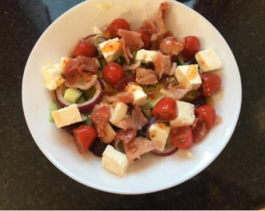
Ingredients
4 Rashers Bacon
½ Lettuce
1 Cucumber
12 Cherry tomatoes
2 beetroot
12 red grapes
Extra virgin olive oil
5oz / 150g Feta Cheese
Instructions
Fry the bacon until crispy and cut into 1” / 2cm pieces.
Shred the lettuce and place on plates.
Cut the cucumber, beetroot & feta cheese into 1” / 2cm pieces.
Slice the cherry tomatoes and grapes in two.
Put the cucumber, tomatoes, beetroot, grapes and feta cheese in a bowl.
Drizzle olive oil over and mix.
The mixture can then be spooned on to the lettuce you plated earlier.
Finally add the warm bacon on top to finish the salad.
Top tip: Substitute the olive oil with sweet chilli sauce for an extra kick
Top

Honey Loaf

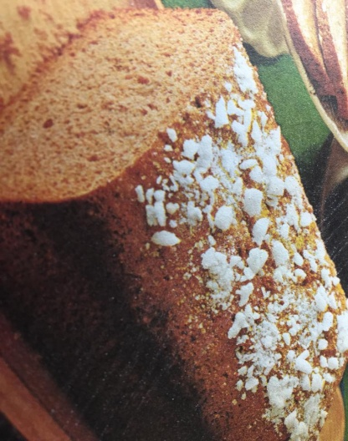
Ingredients

12oz / 350g Self Raising Flour
3 level teaspoons Mixed Spice
4oz / 120g Soft brown sugar
6 fl oz / 170ml Clear Honey
2oz / 60g Mixed peel
¼ Pint / 140ml Milk
1oz / 30g Lump sugar
Instructions

Into a large mixing bowl place, the flour, mixed spice, soft brown sugar, honey, peel and milk.

Mix to a thick batter.

Spoon the batter into a greased 2lb / 1kg loaf tin
and bake at gas mark 4 / 160c for 1hr 15mins.
Check with a skewer that the cake is cooked through.

When cooled, turn out and decorate with the lump sugar.

Serve sliced and spread with butter.

Top

Prawn Pasta Salad

“This can be eaten as a starter, a side dish,
or just as it is with a crusty slice of bread”

Ingredients

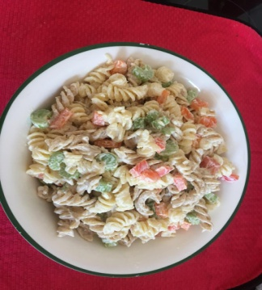
1lb / 500g Pasta
4oz / 120g Cooked peeled prawns
16fl oz /500ml Mayonnaise
2 Sticks celery
1 Red pepper
1 Orange pepper

Instructions
Boil the pasta until soft. Drain and leave to cool.
While the pasta is cooling prepare the other ingredients:
Wash and drain the prawns.
Chop the celery into thin slices.
Slice the pepper into small pieces.

When the pasta has cooled transfer to a large mixing bowl.
Stir in the mayonnaise.

Finally add the remaining ingredients and mix well.

Top Tip: Feeling decadent – replace the prawns with crab meat or pieces of cooked salmon
Top

Rhubarb Crumble Cake

Ingredients
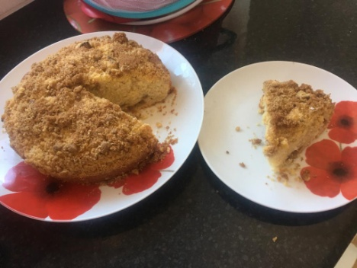
10oz / 300g Flour
5 oz / 150g Butter
2oz / 60g White sugar
2 Eggs
2 tbs Milk
2 large stick Rhubarb
250ml Orange Juice
1oz / 30g Brown Sugar
Instructions

Chop the rhubarb into pieces and put it in a saucepan along with the orange juice. Cook on a low heat until the rhubarb is soft but not mushy. When cooked, drain and leave to cool.

Into a large mixing bowl place 8oz / 220g of the flour,
4oz / 120g of the butter,
White sugar, eggs and milk.
Mix the ingredients together.

Now add half of the rhubarb and mix.
Pour the batter into a greased 7” / 18cm cake tin and prepare the crumble topping

To make the crumble topping, mix the remaining flour and butter along with the brown sugar. When a crumble consistency has been achieved stir in the remaining rhubarb spoon by spoon making sure that the crumble doesn’t become too wet.
Spread the crumble over the cake mix.
Bake at gas mark 4 / 160c for 50mins. Check with a skewer that the cake is cooked.
Top
Lasagne

Ingredients
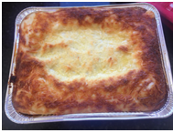
1lb/500g Beef Mince
1 Large red onion
4oz/120g Mushrooms
1 Tin chopped tomatoes
1 Jar Bolognese sauce
1 packet of Lasagne sheets
1 Jar White sauce
4oz/120g Cheddar cheese

Instructions

Cook the mince in a saucepan and drain off any excess fat.
Dice the onion and Mushrooms.
Mix the mince, onion, mushroom, tomatoes and bolognaise sauce.
Grease a large oven dish and then cover the bottom with some of the lasagne sheets (4 should be enough).
Add some of the white sauce,
then a layer of meat mix,
then more lasagne sheets,
Then sauce,
then meat and finally another layer of lasagne sheets.
Grate the cheese and add to the top of the lasagne.
Cook in an oven at gas mark 4 / 160c for 1 hour.

Ann’s Top Tip
Use spinach pasta for a colourful change
Top

Meat Balls & Spaghetti

Ingredients
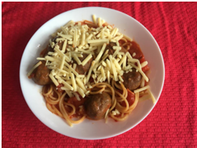
1lb/500g Beef Mince
2 Red onions
1 Egg
1 packet of bolognaise sauce mix
1 Tin of Chopped tomatoes
1lb/500g Spaghetti
Grated Cheese (to taste)

Instructions
Fry the mince and leave to cool.
Chop the onions finely and fry in a little oil.
When cooled put the mince and onions into a large mixing bowl.
Beat the egg and add to the bowl.
Using your hands bind the mixture together and then form your meatballs with your hands and put them in a baking tin.
Mix the bolognaise sauce following the instructions on the packet.
Mix in the tomatoes and pour over the meatballs
Bake at Gas mark 5 / 180c for 15 minutes.
Boil the spaghetti until soft.
Mix everything together in a large bowl and serve topped with grated cheese.

Top

